Synapto Catcher Tutorial

# Opening files

To get started, you need to select an image file. Click the browse button and navigate to the directory containing your image files. Select the desired picture file.

# Settings

## Stacking Parameters

Since the images are multi-layered, you need to select the range of layers to be stacked “**slice start**” (the first slice number), “**slice end**” (the last slice number). You can also check the “**select all slices**” checkbox to use the entire range of layers. Select “**target_ch**”, this is the channel that we analyze. Sometimes it makes sense to select an “**additional channel**”, this channel can help visualize some data more easily, but this channel is not analyzed. Select “**pixel_to_micron_ratio**”, this ratio will allow you to precisely calculate the area occupied by objects in “**target_ch**”.

## Filtering

Filtering helps to remove background noise and to set the desired size of the objects (spots). For example, if you know that the radius of objects should be about 17 pixels, then set the filtering radius to be the same.

## Binarization

Binarization will give a black and white image on which the objects we need will be indicated in black. Choose the “**binarization method”** (e.g., otsu) from the dropdown menu. Specify the “**minimum size”** and the “**maximum size”** of an object. These size options will allow you to keep objects that fall within this area range.

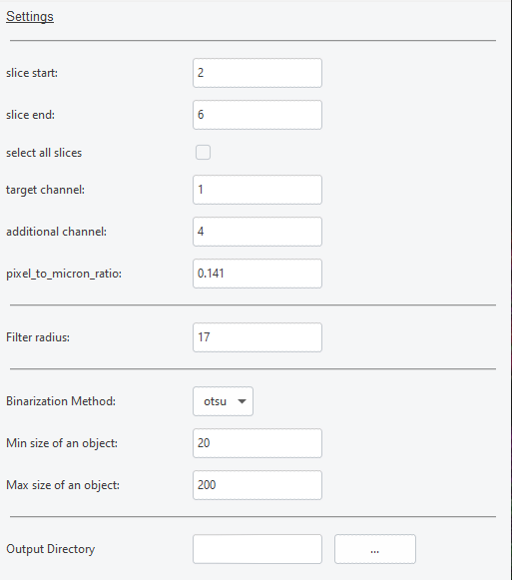

# Data processing

## Region selection

Click **“1. Mark region”** button to choose the Region of Interest (ROI) for the current image.

Come up with a name for the region, by default just “**region**” and click OK button.

Once you do this, the target image will open. In order to start selecting ROI you need to click on the "**Start**" button.

After clicking on "Start", you need to start drawing the region you want to analyze.

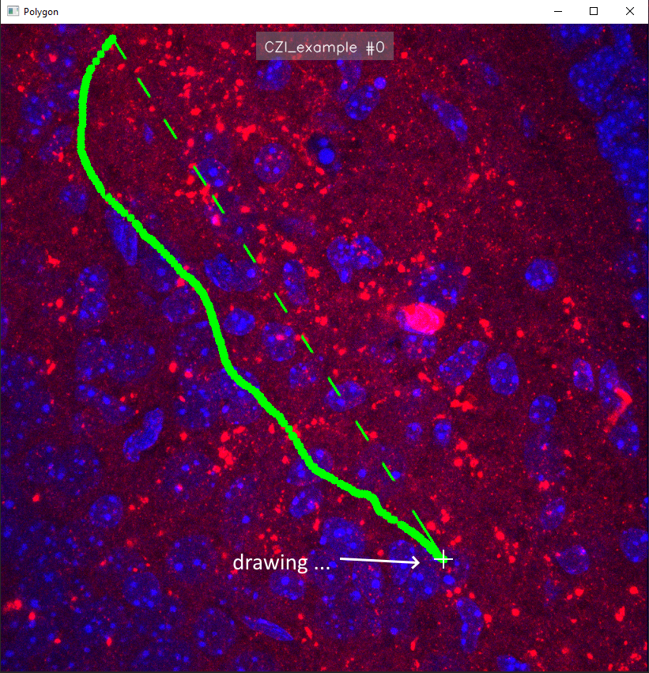

When you finished drawing the region, you can start over by clicking on “**Delete**”, you can accept the region by clicking on “**Apply**” and precisely modify the region by clicking on “**Modify**”.

## Filtering and binarization

To filter and binarize the selected region and get the results of object counting, click on “**2. Filter and Binarize**” button. Filtering and binarization will be performed according to the settings you have set. If the first step of selecting regions was done correctly, you will see a message in the console at the bottom that the “**binarization was successful**”.

# Exploring results

Once you have completed all the data processing steps, you can look at the results by double-clicking on the preview of your image.

After that, a gallery of results will open.

By double-clicking on the previews of the results, you can take a better look at them.

And if you want to see the results files, click on the "**Open Results Folder**" button. In that folder with the results you will find not only pictures with the steps, but also tables with the results of area calculations, and additionally tables with the coordinates of the selected regions.